Implementation and Study of Fuzzy based KY Boost Converter for Electric Vehicle Charging

Dr.Jalla Upendar¹, Sangem.Ravi Kumar², Sapavath Sreenu³, Bogimi Sirisha⁴
¹Assistant Professor Department of Electrical Engineering, Osmania University, Hyderabad, India
²PG Student, Department of Electrical Engineering, Osmania University, Hyderabad, India
³(Ph.D) Research Scholars, Department of Electrical Engineering, Osmania University, Hyderabad, India
⁴Associate Professor Department of Electrical Engineering, Osmania University, Hyderabad, India

Article Info |  | ABSTRACT
Article history: |  | EV batteries require DC current for charging, hence the circuit AC current is converted to DC by a battery charger. Battery charger mostly consists of a rectifier and DC-DC converter with a controller built in to serve as a protective circuit. A harmonic source load is a type of electric car charger. During the AC-DC change over method, harmonic current is introduced into the power system, affecting power quality. In this study, a charging station consisting of buck boost and a charging station consisting a KY Boost converter were simulated. To maintain output voltage of DC-DC converters constant controller is used, the controller are either PI or fuzzy logic controller. So four models are developed and simulated which are Buck-Boost converter controlled by PI-controller, KY-Boost converter controlled by PI-controller, Buck Boost converter controller Fuzzy logic controller and KY Boost- converter controlled by Fuzzy logic controller. The THD of the four models are compared.
Keywords:
Fuzzy Logic Controller
Electric Vehicle
KY Boost Converter

 |  | This is an open access article under the CC BY-SA license.
Corresponding Author:
Dr. Jalla Upendar
Department of Electrical Engineering,
University College of Engineering (A)
OsmaniaUniversity,Hyderabad,Telangana-500007, India
Email: dr.8500003210@gmail.com.

- INTRODUCTION
Electric vehicles will play a critical part in resolving energy shortages and environmental degradation issues since they emit less pollution and consume less energy. Electric vehicles are becoming more environmentally friendly than gasolinepowered vehicles, which is being pushed by automakers' desire to sell zero-emission automobiles. Electric vehicles provide roughly 60% more mileage for the same amount of raw energy, demonstrating outstanding energy conservation. Electric cars have the potential to enhance the energy structure, save energy, and reduce emissions [1]. As civilization progresses, more electric vehicles will become available to the general public, necessitating the installation of a massive number of charging points at the same instant. Electric vehicles are charged quickly and easily at home or at a charging station. Electric vehicles could be recharged during low-load periods, which occur frequently after midnight, reducing peak load and boosting valley load, resulting in increased power system efficiency. Large volumes of harmonic are produced while charging of electric vehicles due to the presence of converters, and if the harmonics is not regulated properly, it may cause huge damage to the power system [2].Harmonic current in large quantities can increase system line loss, add to the problem of electric gear warming, cause control equipment failure, interrupt production or function, and possibly cause a huge shutdown [3].
Advantages of Electric Vehicles
The popularity of electric vehicles is primarily due to this factor. If you want to reduce one’s own environmental footprint while still having mobility, an EV is the method to go. Because the electric car of an EV is closed-loop, it does not emit any greenhouse emissions. A fully electric vehicle eliminates the need for gas or oil, lowering your carbon footprint. One may save a lot of money on oil because spending money on petrol or oil to keep your automobile running is more, and the cost of electric energy is low [4]. Cars, as we all know, require regular maintenance. Unlike petrol vehicles, electric vehicles do not require costly vehicle service. What is the logic for this? A traditional combustion engine does have a large number of mechanical parts that can fail, but an electric vehicle has only few components. This indicates that, in relative to those other vehicles, your EV should have fewer long-term operational costs. The capability of electric vehicles has increased as more businesses entering the industry with their own new take on the car. Electric automobiles are small and light, with startling acceleration capabilities due to the fact that they generate all of their energy from a standstill [5].
Disadvantages of Electric Vehicles
Although electric vehicles cannot travel as far as a conventional car, the distance that can be travelled on a single charge has increased significantly in recent years and will continue to do something in the future [6]. Many of todays more prevalent electric vehicles can now drive 80 to 100 kilometers or more on a single charge. Charging an electric vehicle takes longer. As according statistics, 80% of Electric Vehicles charging occurs at home over the course of a night, which is sufficient for the majority of usage.
Chargers are the primary source of energy for electric vehicles. The charger’s major components are the rectifier and inverter [7]. With widespread use of the charger, the charger will become a new harmonic source, impacting the power grid’s power quality and stability. With increase in Electric vehicles use the demand on the power grid increases so as to maintain the grid stable the generation has to be increased to meet the increased load demand.

- PROPOSED METHOD
The block diagram of proposed model is in following figure 1
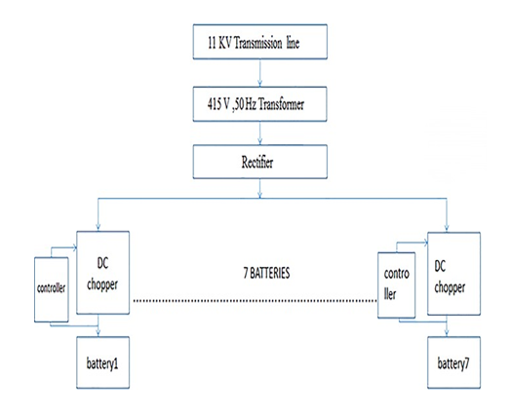

Figure 1. Proposed model Block diagram
In this model power is taken at 11KV and it is step down to 415V and then to 120V using two three phase transformer. The output of the 415V/120V transformer is given to “three phase controlled thyristor bridge rectifier”. The DC out put is given to seven DC-DC converters. In this model either KY Boost or the Buck Boost converter are being used. To control the load voltage of converter a controller is used.In this model either PI or Fuzzy Logic controller is used. So four models are developed they are:

A. Buck-Boost converter controlled by “PI controller”
B. Buck-Boost-controlled by “Fuzzy Logic Controller”
C. KY Boost-controlled by “PI controller
D. KY Boost controlled with “Fuzzy Logic Controller”
The Harmonics of Current generated by four different models are be examined

3 KY BOOST CONVERTER
As stated below, Figure 1 displays the proposed “KY boost converter”, which consists of a “KY –converter” and a “conventional SR-boost-converter”. KY- Boost converter Its made up of switches S₂, S1, a (D_{b}) the diode, (C_{b}) the energy-transferring-capacitor, (L_{o}) the load side inductor & (C_{o}) the load side capacitor [9]. In addition, the KY converter's input is substituted with one buffer capacitor-C_{m}. In contrast, a conventional “SR-boost converter” made up of switches S₂ and S₁ and (L_{i}) the input-inductor. Furthermore, buffer capacitor (C_{m}) serves as a buffer here with the conventional SR boost converter and KY-converter, in other words, the buffer-capacitor (Cm) replaces output of conventional “SR boost-converter”. One load resistor R_{L} [10] represents the output load.
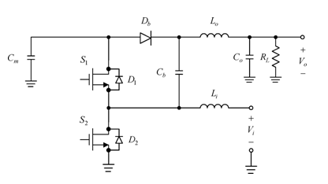
Figure 2. KY Boost converter
Some of the assumptions include the following: i) There is no delay between the power electronic switches; ii) There are zero voltage-drops at switch and diodes throughout on-period; iii) Currents-flowing in the inductors L_{o} and L_{i} were denoted as i_{Lo} and i_{Li}, and iv) (C_{b}) the energy-transfer capacitor which operates wih the principle of “charge pump”,C_{m} is rapidly excited with V_{Cm} in the small time, lesser than the switching period T_{s}[11].
As a result, the converter is operated in two functional modes, switching-on time for the switches are (1-D, D), where D & (1-D) are the duty cycles of switch S₂ and S₁ respectively, duty-cycle (D) for switch S1. Furthermore, because all components are in perfect working order, the voltage at (C_{m}) roughly equals the voltage at (C_{b}).
Mode 1: In Figure 3(a), S₂ is switched on while S₁ is switched off. In this situation,C_{b} cathode terminal is dragged to the ground potential, and D_{b} becomes forward-biased it begins to conduct. In this phase, the C_{m} is deenergized while the C_{b} is charged. As a result, the voltage at L_{i} is V_{i}, making L_{i} to magnetise, but the voltage at L_{o} is V_{o} – V_{Cm}, making L_{o} to discharge. Furthermore, the current through C_{o} Becomes i_{Lo}− i_{RL}, but the current through Cm equals the addition of –i_{Cb} and –i_{Lo}. [13]
Mode2: S₂ is switched off and switch S₁ is switched-on as represented in Figure 3(b). Because S₁ was switched-on during present situation, D_{b} is swiched-off. C_{m} is energised in this mode, whereas C_{b} is denergised. As a consequence the voltage at L_{i} was V_{i}-V_{cm} resulting in L_{i} is discharged, but the voltage at L_{o} was 2V_{Cm}-V₀; resulting in L_{o} is magnetized. Furthermore, the current through C_{o} equals i_{Lo}-i_{RL}, but the current through C_{m} equals to i_{Li} –i_{Lo} [14].
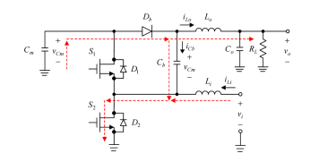
(a)
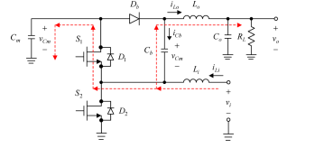
(b)
Figure 3. KY Boost Converter (a) Flow of Power in Mode 1, (b) Flow of Power in Mode 2

As a result, “KY boost-converter” out-put to input voltage-ratio is:
$$\frac{Vo}{Vi}=\frac{2-D}{1-D}$$
4 ELECTRIC VEHICLE
An electric vehicle is one that is propelled by electric motors and draws power from an onboard electric source. It is more durable and has a simpler mechanical design than a gasoline vehicle. Because it does not emit emissions like an internal combustion engine, it has a higher fuel economy than gasoline. However, the automobile industry is not yet fully committed to pure electric vehicles due to an issue with current battery technology. The battery is the most popular storage device used in electric vehicles for storing electric energy. It can store a lot of energy in a small amount of space and weight [15]-[18]. In this model Li-ion Battery with nominal voltage of 320V is used as load at the out put of either “Buck Boost converter” or “KY-Boost converter”.
5 FUZZY LOGIC CONTROLLER
Rules defined by the Linguistic variables are primarily responsible for fuzzy logic control. The model is controlled solely by simple mathematical computations. Despite the fact that it is based on basic mathematics, It has good performance in a control system, according to analysis. As a result, this strategy is one of the most popular. The greatest approaches accessible, as well as one that is easier to control a plant. A Fuzzy-Logic-controller has three important blocks they are i. “Fuzzification,”ii. “Fuzzy Rule-base” and “Interfacing” iii. “De-fuzzification”
In this model there are seven member ship functions for inputs and outputs in this Fuzzy-logiccontroller. The following are the member ship functions:
NH: Negative-Huge, NM: Negative-Moderate,NL: Negative-less,ZO: Zero,PL: Positive-less,PM: Positive-moderate,PH: Positive-Huge
One input to the “Fuzzy logic Controller” given with error voltage that is difference in output voltage to reference voltage [19]-[25]. Second input is difference in error that is difference-between the present error voltages to previous-error voltage. Out-put the “fuzzy-logic” is “duty ratio”. The “fuzzy-logic” works on the rule base.As it has two in-puts and single out-put and seven membership-functions for each input, so total of 49 rules are obtained as shown in following table 1.Where CE is difference in error voltage.
Table 1. Rule base for Fuzzy logic controller
ERROR VOLTAGE

 | NH | NM | NL | ZO | PL | PM | PH
PH  C  E | ZO | PL | PM | PH | PH | PH | PH
PM | NL | ZO | PL | PM | PH | PH | PH
PL | NM | NL | ZO | PL | PM | PH | PH
ZO | NH | NM | NL | ZO | PL | PM | PH
NL | NH | NH | NM | NL | ZO | PL | PM
NM | NH | NH | NH | NM | NL | ZO | PL
NH | NH | NH | NH | NH | NM | NL | ZO

6 MATLAB/SIMULATION RESULTS
In this model up to the rectifier unit for all the three models is same. The rectifier is generating output voltage of 167V.The Mat lab simulation of this model from AC source to output of rectifier is as shown in figure 6,output voltage across the rectifier is as shown in figure 7
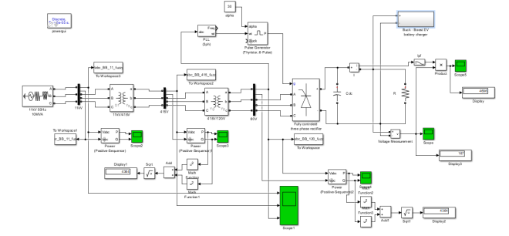
(a)
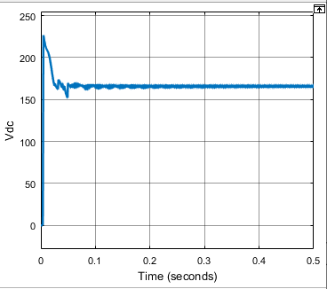
(b)
Figure 4. (a) Mat lab simulation of proposed system, (b) Output Voltage across rectifier

6.1. Buck Boost converter with PI controller
Output of “Three-phase thyristor bridge rectifier” was supplied to seven buck boost converter which is placed in parallel across the AC-DC rectifier. These seven buck-boost converters adjust the DCoutput voltage to feed the seven EV batteries. The controller used is PI controller.
The output voltage for three phase rectifier bridge rectifier for firing angle α=${30}^{0}$is maintained at approximately at a constant value of 167.1V.This 167.1V this 167.1V is utilized by seven buck boost converters. These buck boost converters operate in closed loop. That is the load voltage is subtracted from the reference voltage which is set to 350V.The error signal is the difference between set voltage and load voltage is given to Proportional and Integral controller(PI) .The duty ratio is produced by “PI controller “is given to PWM generator. The simulation results are as shown following figures.
The rectifier and the DC-DC converter are non linear power electronic circuits, so current harmonics are induced in AC side .The current THD at 11KV line is 26.49%Power at the output of rectifier is 3482W.

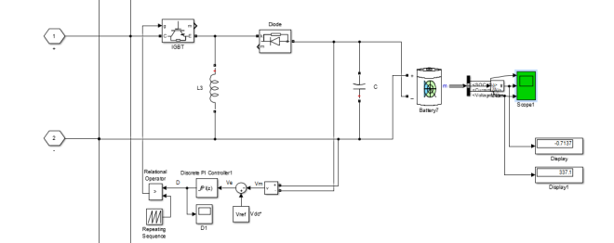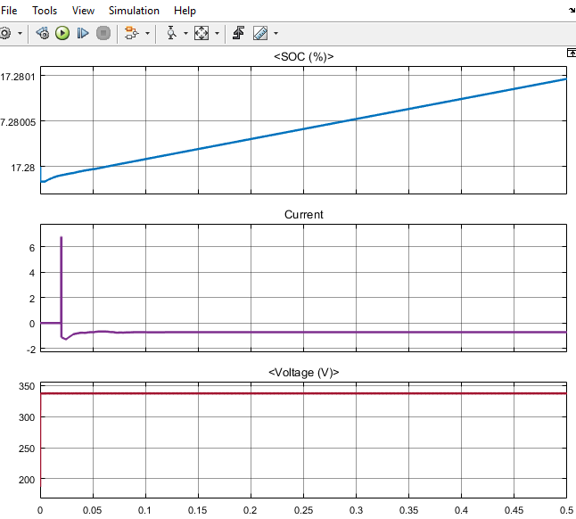
(a) (b)

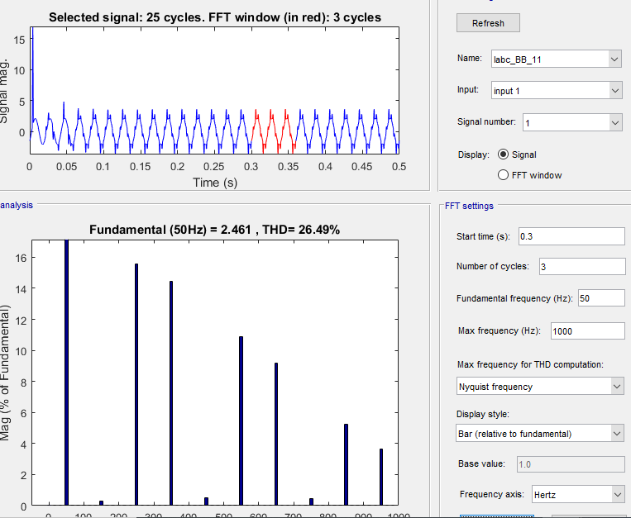
(c)
Figure 5. (a) Closed-loop Buck-Boost converter controlled by PI controller, (b) SOC characteristics, Output voltage, Output Current characteristics of Battery, (c) Current THD at 11KV

6.2. KY Boost Convetrer with PI controller
The output of “three phase thyristor bridge rectifier” was given to seven KY Boost converters which are connected in parallel. These seven KY Boost converters adjust the DC out put voltage to feed the seven EV batteries.The simulation results are as shown in following figures.
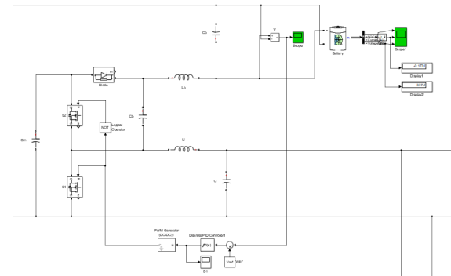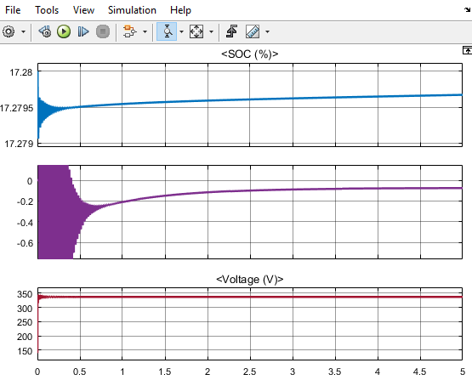
(a) (b)

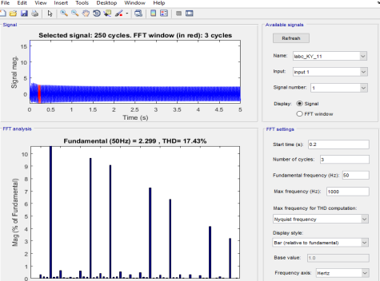
(c)

Figure 6. (a) Closed-loop KY Boost converter controlled by PI controller, (b) SOC characteristics, Output voltage, Output Current characteristics of Battery, (c) Current THD at 11KV.
The rectifier and the DC-DC converter are non linear power electronic circuits, so current harmonics are induced in AC side. The current THD at 11KV line is 17.43%.Power at the output of rectifier is 4078W.

6.3. Buck Boost Converter Controlled With Fuzzy Logic Controller
Output DC voltage of “Three-phase thyristor bridge rectifier” was given to seven Buck Boost converter which are connected in parallel. These seven Buck Boost converters adjust the DC out put voltage to feed the seven EV batteries.The Buck Boost controlled with “fuzzy-logic-controller”. The output voltage for three phase rectifier bridge rectifier for firing angle α=${30}^{0}$is maintained at approximately at a constant value of 166.9V.This 166.9V is utilized by seven buck boost converters. These buck boost converters operate in closed- loop that is the out-put voltage is compared with set voltage which is set to 350V.The error signal generated, that is difference between the set and output voltage is fed to “Fuzzy logic controller” and also the difference in error was also given as in-put to “fuzzy-logic controller”. Duty ratio is produced by fuzzy logic controller utilizing the rule base, for which switch has to be operated to make error voltage equal to zero. The duty ratio from Fuzzy logic controller out-put is given to drive “pulse width modulation generater” .The pulses are used to drive the switches to control the load voltage. So result battery starts charging. The matlab simulation models are given below.
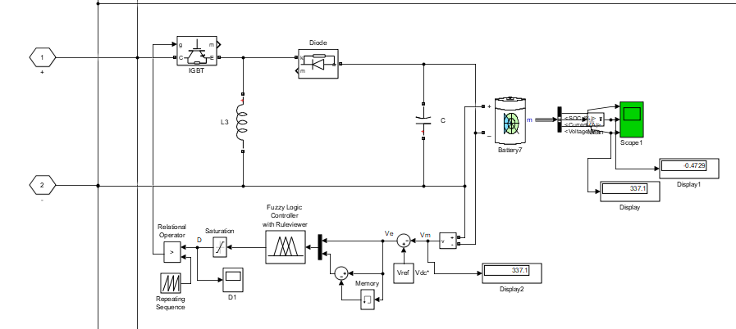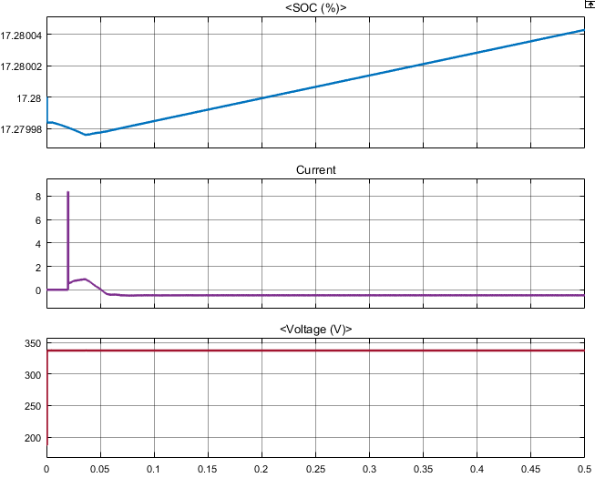
(a) (b)

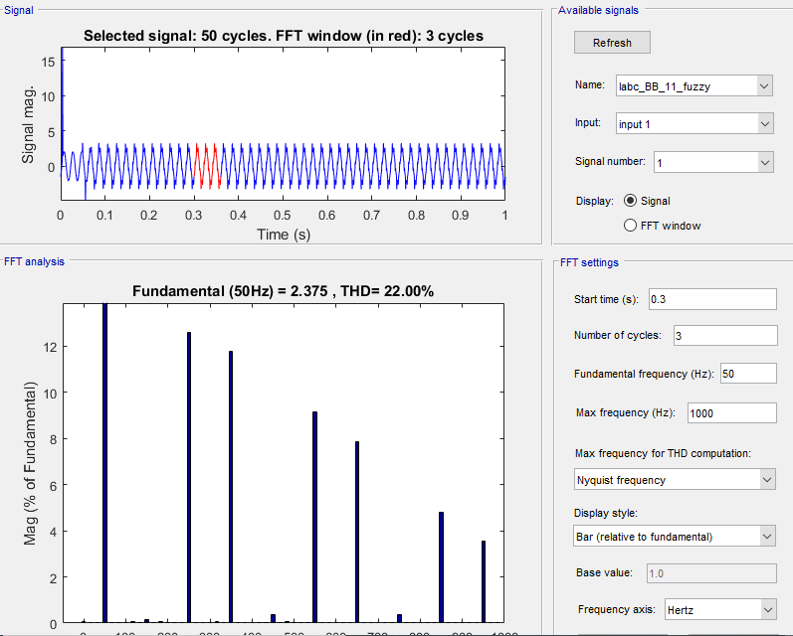
(c)

Figure 7. (a) Closed-loop Buck-Boost converter controlled by Fuzzy logic controller, (b) SOC characteristics, Output voltage, Output Current characteristics of Battery, (c) Current THD at 11KV
The rectifier and the DC-DC converter are non linear power electronic circuits ,so current harmonics are induced in AC side The current THD at 11KV line is 22.00%.Power at the output of rectifier is 4222W.

6.4. KY Boost Converter Controlled With Fuzzy Logic Controller
The output voltage of “three phase thyristor bridge rectifier” was given to seven KY Boost converters which are connected in parallel. These seven KY Boost converters adjust the DC out put voltage to feed the seven EV batteries.The KY Boost converter is operated by fuzzy logic controller. The simulation results are as shown in following figures.
The rectifier and the DC-DC converter are non linear power electronic circuits ,so current harmonics are induced in AC side The current THD at 11KV line is 13.38%.Power at the output of rectifier is 3826W
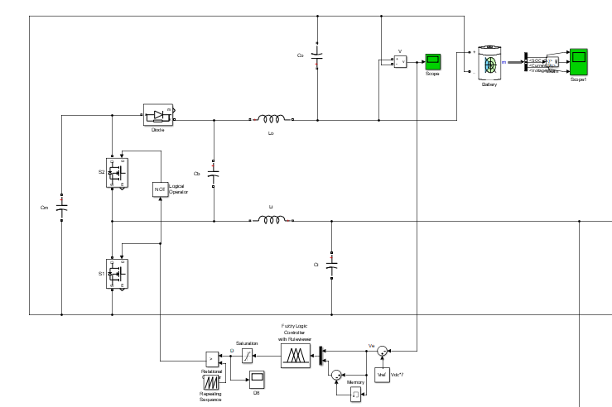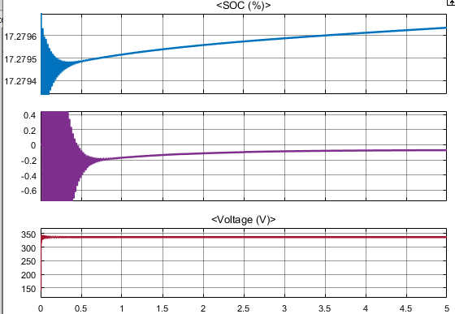
(a) (b)

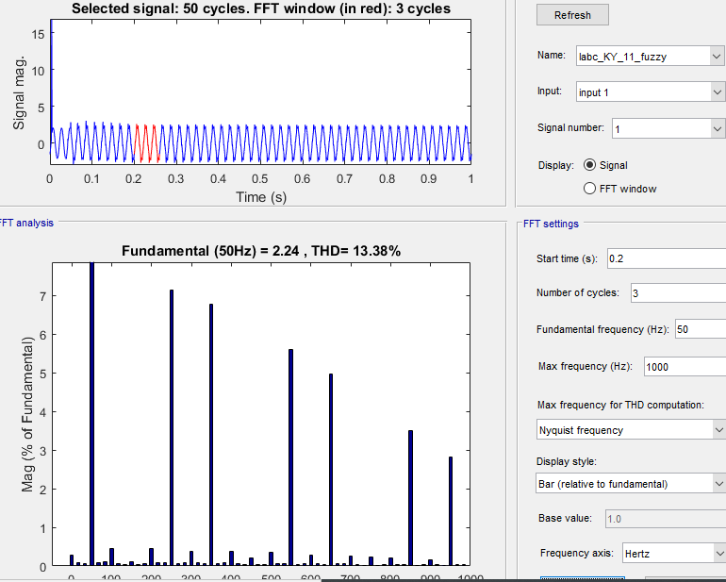
(c)

Figure 8. (a) Closed-loop Buck-Boost converter controlled by PI controller, (b) SOC characteristics, Output voltage, Output Current characteristics of Battery, (c) Current THD at 11KV

7 THD, POWER COMPARISIONS AND FUTURE SCOPE
By comparing the four charges THD with the charger with KY Boost-converter controlled with “fuzzy-logic controller” has lowest harmonic contamination in terms of voltage and current so it is better to have charger with KY Boost-converter controlled with “fuzzy logic controller” out of four charges.
The harmonics can be effectively reduced by designing compensating equipments, so that these compensators will supply harmonics and the grid will supply only the fundamental current.

Table 1. THD, Power comparisons
Converter with controller | Current THD at 11KV | Power at the Rectifier output
Buck Boost converter with PI controller | 26.49% | 3482W
KY Boost converter with PI controller | 17.43% | 4078W
Buck Boost converter with Fuzzy logic  controller | 22.00% | 4222W
KY Boost converter with Fuzzy logic controller | 13.38% | 3826W

REFERENCES
[1] Wenhai Yang, Jingmin Wang, Zhanlong Zhang, Yajing Gao. "Simulation of electric vehicle charging station and harmonic treatment" , 2012 International Conference on Systems and Informatics (ICSAI2012), 2012.
[2] Anil Megha, N Mahendran, Rajan Elizabeth. "Analysis of Harmonic Contamination in Electrical Grid due to Electric Vehicle Charging" , 2020 Third International Conference on Smart Systems and Inventive Technology (ICSSIT), 2020.
[3] K. I. Hwu, Y. T. Yau. "A KY Boost Converter" , IEEE Transactions on Power Electronics, 2010.
[4] R. Vinayakumar, M. Alazab, K. P. Soman, P. Poornachandran, A. Al-Nemrat, and S. Venkatraman, “Deep Learning Approach for Intelligent Intrusion Detection System,” IEEE Access, vol. 7, pp. 41525–41550, 2019, doi: 10.1109/ACCESS.2019.2895334.
[5] K. Sivaraman, R. M. V. Krishnan, B. Sundarraj, and S. Sri Gowthem, “Network failure detection and diagnosis by analyzing syslog and SNS data: Applying big data analysis to network operations,” Int. J. Innov. Technol. Explor. Eng., vol. 8, no. 9 Special Issue 3, pp. 883–887, 2019, doi: 10.35940/ijitee.I3187.0789S319.
[6] A. D. Dwivedi, G. Srivastava, S. Dhar, and R. Singh, “A decentralized privacy-preserving healthcare blockchain for IoT,” Sensors (Switzerland), vol. 19, no. 2, pp. 1–17, 2019, doi: 10.3390/s19020326.
[7] F. Al-Turjman, H. Zahmatkesh, and L. Mostarda, “Quantifying uncertainty in internet of medical things and big-data services using intelligence and deep learning,” IEEE Access, vol. 7, pp. 115749–115759, 2019, doi: 10.1109/ACCESS.2019.2931637.
[8] S. Kumar and M. Singh, “Big data analytics for healthcare industry: Impact, applications, and tools,” Big Data Min. Anal., vol. 2, no. 1, pp. 48–57, 2019, doi: 10.26599/BDMA.2018.9020031.
[9] L. M. Ang, K. P. Seng, G. K. Ijemaru, and A. M. Zungeru, “Deployment of IoV for Smart Cities: Applications, Architecture, and Challenges,” IEEE Access, vol. 7, pp. 6473–6492, 2019, doi: 10.1109/ACCESS.2018.2887076.
[10] B. P. L. Lau et al., “A survey of data fusion in smart city applications,” Inf. Fusion, vol. 52, no. January, pp. 357–374, 2019, doi: 10.1016/j.inffus.2019.05.004.
[11] Y. Wu et al., “Large scale incremental learning,” Proc. IEEE Comput. Soc. Conf. Comput. Vis. Pattern Recognit., vol. 2019-June, pp. 374–382, 2019, doi: 10.1109/CVPR.2019.00046.
[12] A. Mosavi, S. Shamshirband, E. Salwana, K. wing Chau, and J. H. M. Tah, “Prediction of multi-inputs bubble column reactor using a novel hybrid model of computational fluid dynamics and machine learning,” Eng. Appl. Comput. Fluid Mech., vol. 13, no. 1, pp. 482–492, 2019, doi: 10.1080/19942060.2019.1613448.
[13] V. Palanisamy and R. Thirunavukarasu, “Implications of big data analytics in developing healthcare frameworks – A review,” J. King Saud Univ. - Comput. Inf. Sci., vol. 31, no. 4, pp. 415–425, 2019, doi: 10.1016/j.jksuci.2017.12.007.
[14] J. Sadowski, “When data is capital: Datafication, accumulation, and extraction,” Big Data Soc., vol. 6, no. 1, pp. 1–12, 2019, doi: 10.1177/2053951718820549.
[15] J. R. Saura, B. R. Herraez, and A. Reyes-Menendez, “Comparing a traditional approach for financial brand communication analysis with a big data analytics technique,” IEEE Access, vol. 7, pp. 37100–37108, 2019, doi: 10.1109/ACCESS.2019.2905301.
[16] D. Nallaperuma et al., “Online Incremental Machine Learning Platform for Big Data-Driven Smart Traffic Management,” IEEE Trans. Intell. Transp. Syst., vol. 20, no. 12, pp. 4679–4690, 2019, doi: 10.1109/TITS.2019.2924883.
[17] S. Schulz, M. Becker, M. R. Groseclose, S. Schadt, and C. Hopf, “Advanced MALDI mass spectrometry imaging in pharmaceutical research and drug development,” Curr. Opin. Biotechnol., vol. 55, pp. 51–59, 2019, doi: 10.1016/j.copbio.2018.08.003.
[18] C. Shang and F. You, “Data Analytics and Machine Learning for Smart Process Manufacturing: Recent Advances and Perspectives in the Big Data Era,” Engineering, vol. 5, no. 6, pp. 1010–1016, 2019, doi: 10.1016/j.eng.2019.01.019.
[19] Y. Yu, M. Li, L. Liu, Y. Li, and J. Wang, “Clinical big data and deep learning: Applications, challenges, and future outlooks,” Big Data Min. Anal., vol. 2, no. 4, pp. 288–305, 2019, doi: 10.26599/BDMA.2019.9020007.
[20] M. Huang, W. Liu, T. Wang, H. Song, X. Li, and A. Liu, “A queuing delay utilization scheme for on-path service aggregation in services-oriented computing networks,” IEEE Access, vol. 7, pp. 23816–23833, 2019, doi: 10.1109/ACCESS.2019.2899402.
[21] G. Xu, Y. Shi, X. Sun, and W. Shen, “Internet of things in marine environment monitoring: A review,” Sensors (Switzerland), vol. 19, no. 7, pp. 1–21, 2019, doi: 10.3390/s19071711.
[22] M. Aqib, R. Mehmood, A. Alzahrani, I. Katib, A. Albeshri, and S. M. Altowaijri, Smarter traffic prediction using big data, in-memory computing, deep learning and gpus, vol. 19, no. 9. 2019.
[23] S. Leonelli and N. Tempini, Data Journeys in the Sciences. 2020.
[24] N. Stylos and J. Zwiegelaar, Big Data as a Game Changer: How Does It Shape Business Intelligence Within a Tourism and Hospitality Industry Context? 2019.
[25] Q. Song, H. Ge, J. Caverlee, and X. Hu, “Tensor completion algorithms in big data analytics,” arXiv, vol. 13, no. 1, 2017.

BIOGRAPHIES OF AUTHORS

Dr. Jalla Upendar
https://scholar.google.co.in/citations?user=gKaJffEAAAAJ&hl=en
he has an Assistant Professor at the Department of Electrical Engineering, University college of Engineering, Osmania university, Hyderabad, India, where he has been a faculty member since 2013. From 2010-2013, he was also the Senior Engineer- Power Electronics Team Development, General Electric (GE Power Conversion) (CVT EDC Private Limited) Chennai-32,India (&in UK, France), And completed his Doctor of Philosophy (Ph.D) in Electrical Engineering from Indian Institute of Technology (IIT), Roorkee, India. His research interests are primarily in the area of Intelligent Approach for Fault Classification of Power Transmission Systems, where he is the author/co-author of over 30 research publications. He can be contacted at email: dr.8500003210@gmail.com.
Sangem Ravi Kumar is PG scholar at the Department of Electrical Engineering, University college of Engineering, Osmania university, Hyderabad, India, And He received Bachelor of Technology (B.Tech) in Electrical and Electronics Engineering, at Gugu Nanak Institute of Technology in 2018. He can be contacted at email: sangem.ravi11@gmail.com.
Sapavath Sreenu
https://scholar.google.com/scholar?scilib=6&hl=en&as_sdt=0,5
he has (Ph.D) Research scholar at the Department of Electrical Engineering, University college of Engineering, Osmania university, Hyderabad, India. He received Master of Technology (M.Tech) in Power Electronics and Electrical Drives (PE&ED) from Anurag Engineering College (Autonomous), Kodad, India in 2014. And He received Bachelor of Technology (B.Tech) in Electrical and Electronics Engineering, SRREC in 2010. He can be contacted at email: sreenu274@gmail.com.
BogimiSirisha https://scholar.google.com/citations?view_op=list_works&hl=en&user=bWpU5F0AAAAJ She holds a B.E. in Electrical Engineering from Osmania University, M. Tech Power Eelectronics from JNTUH in 2003, and a Ph.D. degree from Osmania University 2018. She has over 16 years of experience in research and teaching and is currently employed as an Associate Professor in Electrical Department, Engineering College, Osmania University, Hyderabad INDIA. She has published various articles in international and national journal publications and conferences. Multilevel Inverters, Power Electronics and Drives, Renewable Energy Applications and Special Electrical Machines are among her research interests. Osmania University awarded her a Ph.D. in the field of multilevel inverters. Shee can be contacted at email:sirishab@osmania.ac.in

