ISSN: 2252-8792, DOI: 10.11591/ijape.v12.i1.pp1-12  1

Battery Charger Regulator With Full Controlled Return 15 V / 5 A In Uninterruptable Power Supply

# Rizki Shobirin Hutagalung1, Arnawan Hasibuan1, Kartika1, Muhammad Daud1

1 Department of Electrical Engineering, Universitas, Lhokseumawe, Indonesia

**Article Info ABSTRACT**

***Article history:***

Received Sep 2, 2022

Revised Jan 1, 2023

Accepted Jan 21, 2023

***Keywords:***

Rectifier

Baterai Charger Regulator IC Regulator

Uninterruptable Power Supply

Fully controlled rectifier and BCR. The Battery Charge Regulator (BCR) is the most important unit of the Uninterruptible Power Supply (UPS) device. The BCR uses a 15V / 5 A transformer to lower the voltage so as not to burden the BCR components. A fully controlled rectifier using four thyristors has the function of supplying voltage directly to the BCR, and the BCR has the function of regulating the charge of the battery. Forcing the battery to be charged at a constant voltage with a current equal to the life of the battery affects the shortening of the battery life and also affects the efficiency of using the battery. Controlling the input voltage to the charging battery depends on the battery voltage which will be regulated by the charging current flow rate. The input voltage that comes out of the rectifier will be a dc voltage as a supply for charging the Uninterruptable power supply battery. Battery loading through the BCR is adjusted to match the battery voltage, then allows the BCR to control it by adjusting the phase voltage to 13.5V for High Voltage Discharge (HVD) and 10.5V for Low Voltage Discharge (LVD). By using a fully charged battery Regulator IC it will automatically auto cut off to avoid overcharging the battery which will result in the battery being damaged quickly and shortening battery life. The regulator IC is combined with a relay as a voltage breaker when a charge takes place on the battery. When the maximum voltage is reached, the regulator IC will respond and break the contact on the relay, and charging will stop. Based on the results of testing the performance of a fully controlled rectifier system using a thyristor and BCR on a 12V / 5Ah battery, the output voltage. As a fully controlled 12 V rectifier, the BCR switch can charge the internal battery in minutes with currents varying from 2.1 A to 0.1 A.

*This is an open access article under the CC BY-SA license.*



***Corresponding Author:***

Arnawan Hasibuan

Electrical Engineering Department, Malikussaleh University and Electrical Engineering Laboratory, Lhokseumawe 24355, Indonesia

Email: arnawan@unimal.ac.id

# INTRODUCTION

Computers, especially electronic devices, require a continuous power supply. Uninterruptible Power Supply (UPS) is an electric power system capable of providing power quickly when electronic devices need it, at the right time, avoiding the effects of data loss[1]. The main component supporting the work of the UPS is the rectifier system as a battery charger, enabling the inverter to provide AC power in the event of a power outage from the PLN[2]. In general, a UPS consists of an inverter, battery, battery charger, battery charger control circuit, stabilizer, switch, and indicator. Battery charger control circuitry, also known as BCR, is used to control the battery charging process[3]. When the battery is fully charged, the control system issues a command to break the battery charging circuit[4]. Conventionally, a diode bridge system is used in rectifier circuits and the BCR is only needed as a circuit breaker when the battery voltage is not more than 12 volts[5].

The objective in the design of a fully controlled rectifier and BCR is to produce a control variable voltage and current corresponding to the increase in battery voltage[6].

A fully controlled rectifier with a thyristor and battery charge regulator are the main components of an uninterruptible power supply[7]. The fully controlled rectifier supplies DC voltage to the BCR, which regulates battery charge. Forced charging the battery at constant voltage with a current that matches the resistance of the battery has the effect of shortening the battery life, in addition to the high evaporation effect of the battery liquid[8]. Adjusting the battery supply voltage during charging as a function of battery voltage controls the amount of charging current[9]. Due to these limitations, a Silicon Controller Rectifier (SCR) is used, namely a thyristor where the gate can be adjusted by changing the angle α to adjust the voltage. Based on the problems and explanations above, the authors are interested in discussing and adopting the title "Battery Charger Regulator With Fully Controlled Rectification 15 V / 5 A On Uninterruptable Power Supply".

# PROPOSED METHODOLOGY

UPS (Uninterruptible Power Supply) is a backup power system that is used when the main power supply is interrupted. An uninterruptible power supply can be used as a backup power source at home in the event of a power outage caused by the PLN[10]. This UPS can be used to protect all types of electronic devices that are sensitive to current and voltage instability[11]. The UPS consists of an inverter circuit that can convert DC voltage to AC voltage. So that this tool can be used in electronic equipment that requires an AC power source such as televisions, lamps, and especially computers[12]. Battery Charge Controller is an electronic circuit that controls the process of charging a battery or battery bank (Battery Bank). The DC voltage of a thyristor or rectifier circuit varies from 12 volts and more[13]. This regulator functions as a battery voltage regulator so that it does not exceed its power tolerance limit. In addition, this regulator also prevents the introduction of excess voltage to the battery[14]. When the battery or battery pack is fully charged, the DC in the rectifier will be cut off, so the battery will stop charging to avoid battery damage and extend battery life. Controlling the battery charging process by opening and closing the direct current flow from the rectifier to the battery is the basic function of a battery charge controller. An example of implementing a BCR system is installing BCR on a UPS that uses a battery as a power source for electronic equipment[15]. Thyristors are used as rectifiers, thyristors are semiconductor-based electronic devices that can regulate large currents and voltages. The higher the voltage rises, the higher the current, and conversely, the lower the applied voltage, the less current will flow to avoid surge currents. It is a characteristic of the thyristor that the trigger current initially flows through the gate of the thyristor when the trigger angle is set. By doing this, it takes time to delay the incoming load current so that the firing angle current resolve the firing angle first[16]. The AC voltage from this process is limited so that it is reduced and processed by the thyristor as a DC output. The output waveform corresponding to the thyristor ignition angle is shown in Figure 1 below

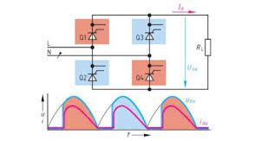

Figure 1. Thyristor Ignition Angle

Angle adjustment switch between 0̊ and 90̊. This is because the thyristor no longer functions as a corner rectifier at an angle of more than 90° or 90° to 180° but as an inverter.

When the voltage between the anode and cathode is increased to a certain degree, the reverse voltage across J2 is cut off (transparent) and the pressure at that moment is called the forward voltage (VBO). Since J1 and J3 are still forward-biased, current flows from the anode to the large cathode across the three junctions J1, J2, and J3. At this time, the SCR is conducting or in a conducting state. the voltage between the anode and cathode is

very small (± 1 volt) or drops so far that it penetrates. A, the anode-cathode current depends on the load current

(load impedance)[17]. The anode-cathode current must be greater than the reverse current IL so that the current continues to flow through the junction, namely H. The SCR returns to the off state when the anode-cathode voltage drops[18]. When the cathode is more positive than the anode, the junctions of J2 are forward-biased, and J1 and J3 are reverse-biased. The characteristics of the thyristor can be seen in Figure 2 below.

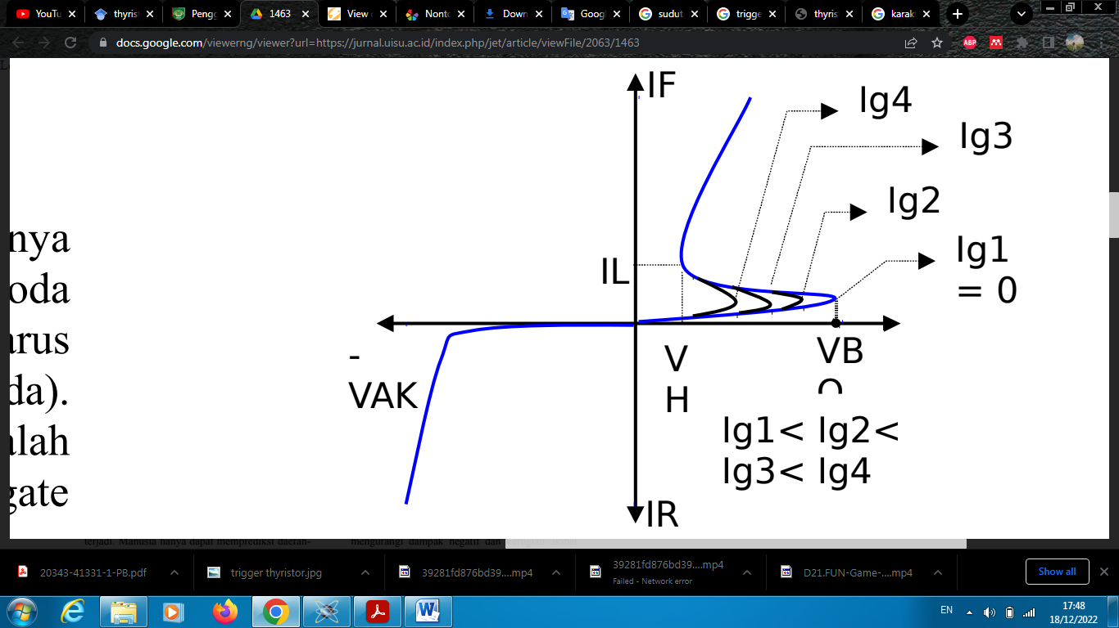

Figure 2. Thyristor Characteristics

As already explained, the SCR is conducting, it remains conductive even if the gate current is removed, i.e. a power failure of the SCR changes the state from conducting (ON) to non-conducting (OFF)[19]. Substitution or substitution is the process of turning off the SCR. Type of replacement process, for example:

1. Natural switching occurs when the SCR is powered by AC mains[20].
2. Forced switching, is carried out when the SCR is given a current source in the same direction, including through a source discharge (supply) or a short circuit between A and K for a moment[21].
3. **SIMULATION DIAGRAM AND RESULTS**

**3.1 Circuits Design**

The electrical design is divided into several parts, namely the design of components in the BCR circuit, several things will be tested in this circuit, namely testing of thyristors, regulator ICs, relays, and batteries. From several testing components, it is necessary to design a rectifier and voltage regulator. The following is a schematic diagram of the electrical design



Figure 3. Schematic Diagram of a Rectifier

In the rectifier circuit, four SCRs will be used, namely thyristors with the bridge method which will produce a voltage output in the same direction with a voltage value that can be adjusted according to the ignition gate. The voltage waveform produced by the rectifier still has ripple or ripple and is not perfect, therefore after the rectifier circuit, the elco will be used as an output wave filter.



Figure 4. Schematic Diagram of Voltage Regulator L7812

Figure 4 above is a voltage regulation circuit that regulates the output voltage to a maximum of 12 volts dc, this component can be called a stabilizer which is useful so that the voltage remains constant when charging the battery.



Figure 5. Schematic diagram of the overall electrical circuit

Figure 5 is an overall schematic diagram using a series of rectifiers, voltage regulators, and auto cut-off arrangements.

**3.2 Electronic Design**

The electrical design is specifically designed according to the design of the battery charger regulator. In the BCR circuit, the components used are 4 Thyristors BT151, ELCO, IC L7812, Resistors, Transistors, Diodes, Zener, Relays, and loads, namely 12V / 5A Batteries. The application of BCR is for the voltage regulator for charging the battery to a power bank or Uninterruptable Power Supply battery. BCR electronic design drawings can be seen in Figure 6. the following.

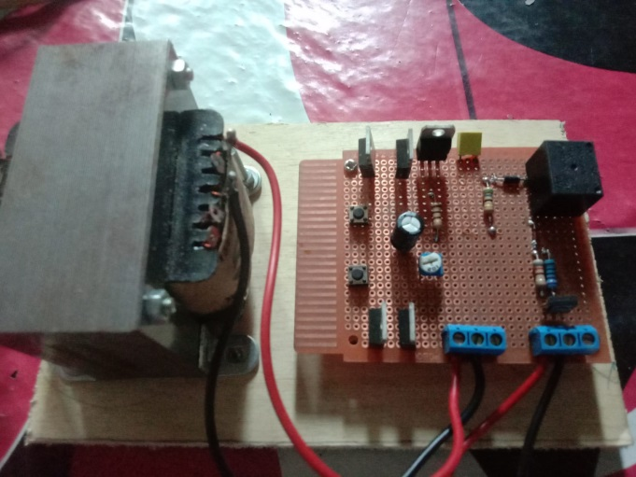

Figure 6 Electronic Design of Battery Charger Regulator

Table 1. Thyristor Test Results

|  |  |  |  |  |
| --- | --- | --- | --- | --- |
| No | *Input* | Sudut | Output | |
| V | I |
| 1 | 15 Volt AC | 15° | 11,22 Volt AC | 0,1058 A |
| 2 | 15 Volt AC | 30° | 10,45 Volt AC | 0,1045 A |
| 3 | 15 Volt AC | 45° | 10,10 Volt AC | 0,1010 A |
| 4 | 15 Volt AC | 90° | 8,71 Volt AC | 0,0749 A |
| 5 | 15 Volt AC | 180° | 3,18 Volt AC | 0,0318 A |

Table 2. Transistor and Relay Test Results

|  |  |  |
| --- | --- | --- |
| No | Tegangan | Status Relay |
|
| 1. | 11,11 V | Close |
| 2. | 11,56 V | Close |
| 3. | 12,59 V | Close |
| 4. | 13,45 V | Open |

Table 3. L7812 Regulatory IC Test Results

|  |  |  |  |
| --- | --- | --- | --- |
| No | Nilai Resistor | Tegangan | Status Kinerja Sistem |
|
| 1. | 20 % | 12,11 V | Baik |
| 2. | 40 % | 12,39 V | Baik |
| 3. | 60% | 12, 72 V | Baik |
| 4. | 70 % | 12,90 V | Baik |
| 5. | 80 % | 13,45 V | Baik |

In this test, the use of the BCR circuit will be carried out in charging the UPS battery. In this case, we will pay attention to the source voltage across the thyristor and the voltage on the battery side and the charging current of the battery

Table 4. Battery Charging Test Results

|  |  |  |  |  |  |
| --- | --- | --- | --- | --- | --- |
| No | Tegangan Masuk | Arus | Tegangan Baterai (DC) | Status Pengisian | Waktu (Menit) |
| 1. | 12,11 V | 2,04 A | 10,12 V | ON | 0 |
| 2. | 12,20 V | 2,02 A | 10,34 V | ON | 60 |
| 3. | 12,39 V | 2,01 A | 10,45 V | ON | 120 |
| 4. | 12,48 V | 2,0 A | 10,60 V | ON | 180 |
| 5. | 12,56 V | 1,8 A | 10,70 V | ON | 240 |
| 6 | 12,72 V | 1,6 A | 11,30 V | ON | 300 |
| 7 | 12,77 V | 1,4 A | 11,45 V | ON | 360 |
| 8 | 12,90 V | 0,55 A | 11,66 V | ON | 420 |
| 9 | 13,1 V | 0,45 A | 11,76 V | ON | 480 |
| 10 | 13,20 V | 0,36 A | 11,89 V | ON | 540 |
| 11 | 13,43 V | 0,22 A | 12,00 V | ON | 600 |
| 12 | 13,45 V | 0,10 A | 12,09 V | OFF | 719 |

# CONCLUSION

The conclusions from the research results of the Battery Charger Regulator with a fully controlled rectifier 15 V / 5 A on an Uninterruptable Power Supply are The design and manufacture of a Battery Charger Regulator with a fully controlled rectifier 15 V / 5 A on an Uninterruptable Power Supply have been successful and are following the initial goal of being able to regulate the charging voltage and automatic cut-off of the battery. Based on the test results of the performance of the BCR system, the use of a fully controlled rectifier in the BCR system functions to change the AC voltage from the source (PLN) to DC whose output can be adjusted from 0-12 Volts to then be input for charging the battery. Regulator IC 7812 regulates the voltage rather than charging the battery does not exceed a predetermined limit.

# REFERENCES

[1] S. Vazquez, E. Zafra, R. P. Aguilera, T. Geyer, J. I. Leon, and L. G. Franquelo, “Prediction model with harmonic load current components for FCS-MPC of an uninterruptible power supply,” *IEEE Trans. Power Electron.*, vol. 37, no. 1, pp. 322–331, Jan. 2022, doi: 10.1109/TPEL.2021.3098948.

[2] D. Shahzad, S. Pervaiz, N. A. Zaffar, and K. K. Afridi, “GaN-Based High-Power-Density AC-DC-AC Converter for Single-Phase Transformerless Online Uninterruptible Power Supply,” *IEEE Trans. Power Electron.*, vol. 36, no. 12, pp. 13968–13984, Dec. 2021, doi: 10.1109/TPEL.2021.3089079.

[3] Q. Lin, F. Cai, W. Wang, S. Chen, Z. Zhang, and S. You, “A High-Performance Online Uninterruptible Power Supply (UPS) System Based on Multitask Decomposition,” *IEEE Trans. Ind. Appl.*, vol. 55, no. 6, pp. 7575–7585, Nov. 2019, doi: 10.1109/TIA.2019.2935929.

[4] M. Ferraro, G. Brunaccini, F. Sergi, D. Aloisio, N. Randazzo, and V. Antonucci, “From Uninterruptible Power Supply to resilient smart micro grid: The case of a battery storage at telecommunication station,” *J. Energy Storage*, vol. 28, p. 101207, Apr. 2020, doi: 10.1016/J.EST.2020.101207.

[5] E. O. Prado, P. C. Bolsi, H. C. Sartori, and J. R. Pinheiro, “Comparative Analysis of Modulation Techniques on the Losses and Thermal Limits of Uninterruptible Power Supply Systems,” *Micromachines 2022, Vol. 13, Page 1708*, vol. 13, no. 10, p. 1708, Oct. 2022, doi: 10.3390/MI13101708.

[6] Q. Ouyang, Z. Wang, K. Liu, G. Xu, and Y. Li, “Optimal Charging Control for Lithium-Ion Battery Packs: A Distributed Average Tracking Approach,” *IEEE Trans. Ind. Informatics*, vol. 16, no. 5, pp. 3430–3438, May 2020, doi: 10.1109/TII.2019.2951060.

[7] D. Venkatramanan and V. John, “Dynamic Modeling and Analysis of Buck Converter Based Solar PV Charge Controller for Improved MPPT Performance,” *IEEE Trans. Ind. Appl.*, vol. 55, no. 6, pp. 6234–6246, Nov. 2019, doi: 10.1109/TIA.2019.2937856.

[8] M. Zhao, S. Zhong, X. Fu, B. Tang, S. Dong, and M. Pecht, “Deep Residual Networks with Adaptively Parametric Rectifier Linear Units for Fault Diagnosis,” *IEEE Trans. Ind. Electron.*, vol. 68, no. 3, pp. 2587–2597, Mar. 2021, doi: 10.1109/TIE.2020.2972458.

[9] S. A. Rotenberg, S. K. Podilchak, P. D. H. Re, C. Mateo-Segura, G. Goussetis, and J. Lee, “Efficient Rectifier for Wireless Power Transmission Systems,” *IEEE Trans. Microw. Theory Tech.*, vol. 68, no. 5, pp. 1921–1932, May 2020, doi: 10.1109/TMTT.2020.2968055.

[10] A. K. Venkitaraman and V. S. R. Kosuru, “Hybrid Deep Learning Mechanism for Charging Control and Management of Electric Vehicles,” *Eur. J. Electr. Eng. Comput. Sci.*, vol. 7, no. 1, pp. 38–46, Jan. 2023, doi: 10.24018/EJECE.2023.7.1.485.

[11] A. F. Bendary and M. M. Ismail, “Battery Charge Management for Hybrid PV/Wind/Fuel Cell with Storage Battery,” *Energy Procedia*, vol. 162, pp. 107–116, Apr. 2019, doi: 10.1016/J.EGYPRO.2019.04.012.

[12] N. I. Nimalsiri, C. P. Mediwaththe, E. L. Ratnam, M. Shaw, D. B. Smith, and S. K. Halgamuge, “A Survey of Algorithms for Distributed Charging Control of Electric Vehicles in Smart Grid,” *IEEE Trans. Intell. Transp. Syst.*, vol. 21, no. 11, pp. 4497–4515, Nov. 2020, doi: 10.1109/TITS.2019.2943620.

[13] X. Zhu *et al.*, “Silicon-Controlled Rectifier Embedded Diode for 7 nm FinFET Process Electrostatic Discharge Protection,” *Nanomater. 2022, Vol. 12, Page 1743*, vol. 12, no. 10, p. 1743, May 2022, doi: 10.3390/NANO12101743.

[14] F. Du *et al.*, “An improved silicon-controlled rectifier (SCR) for low-voltage ESD application,” *IEEE Trans. Electron Devices*, vol. 67, no. 2, pp. 576–581, Feb. 2020, doi: 10.1109/TED.2019.2961124.

[15] K. Il Do, B. Lee, S. G. Kim, and Y. S. Koo, “Design of 4H-SiC-Based Silicon-Controlled Rectifier with High Holding Voltage Using Segment Topology for High-Voltage ESD Protection,” *IEEE Electron Device Lett.*, vol. 41, no. 11, pp. 1669–1672, Nov. 2020, doi: 10.1109/LED.2020.3022888.

[16] S. Singh, P. Rathore, V. K. Tayal, and S. K. Sinha, “Improved Design of Automatic Car Battery Charging System,” *2019 2nd Int. Conf. Power Energy Environ. Intell. Control. PEEIC 2019*, pp. 1–5, Oct. 2019, doi: 10.1109/PEEIC47157.2019.8976567.

[17] P. Renz, M. Lueders, and B. Wicht, “A 47 MHz Hybrid Resonant SC Converter with Digital Switch Conductance Regulation and Multi-Mode Control for Li-Ion Battery Applications,” *Conf. Proc. - IEEE Appl. Power Electron. Conf. Expo. - APEC*, vol. 2020-March, pp. 15–18, Mar. 2020, doi: 10.1109/APEC39645.2020.9124238.

[18] Z. Li, X. Shi, M. Shi, C. Wei, F. Di, and H. Sun, “Investigation on the Impact of the HPPC Profile on the Battery ECM Parameters’ Offline Identification,” *2020 Asia Energy Electr. Eng. Symp. AEEES 2020*, pp. 753–757, May 2020, doi: 10.1109/AEEES48850.2020.9121487.

[19] H. Tafekirt, J. Pelegri-Sebastia, A. Bouajaj, and B. M. Reda, “A Sensitive Triple-Band Rectifier for Energy Harvesting Applications,” *IEEE Access*, vol. 8, pp. 73659–73664, 2020, doi: 10.1109/ACCESS.2020.2986797.

[20] M. Li and X. Jing, “A bistable X-structured electromagnetic wave energy converter with a novel mechanical-motion-rectifier: Design, analysis, and experimental tests,” *Energy Convers. Manag.*, vol. 244, p. 114466, Sep. 2021, doi: 10.1016/J.ENCONMAN.2021.114466.

[21] M. M. Mansour and H. Kanaya, “High-Efficient Broadband CPW RF Rectifier for Wireless Energy Harvesting,” *IEEE Microw. Wirel. Components Lett.*, vol. 29, no. 4, pp. 288–290, Apr. 2019, doi: 10.1109/LMWC.2019.2902461.