ISSN: 2252-8792, DOIs: 10.11591/ijape.v12.i1.pp1-12    1

Battery Charger Regulator with Fully Controlled Return 15 V / 5 A In Uninterruptible Power Supply

# Arnawan Hasibuan1, Muhammad Daud1, Rizki Shobirin Hutagalung 1, Kartika 1, I Made Ari Nrartha2, Rizky Almunadiansyah1

# 

1 Department of Electrical Engineering, Universitas Malikussaleh, Lhokseumawe, Indonesia

1 Department of Electrical Engineering, Mataram University, Matarm, Indonesia

|  |  |  |
| --- | --- | --- |
| **Article Info** |  | **ABSTRACT** |
| ***Article history:***  Received 2 Sept. 2022  Fixed January 1, 2023  Received 21 Jan, 2023 |  | Fully controlled rectifier and BCR. The Battery Charge Regulator (BCR) is the most important unit of an Uninterruptible Power Supply (UPS) device. The BCR uses a 15V/5A transformer to lower the voltage so as not to overload the BCR components. Full control using four thyristors serves to supply voltage to the BCR, while the BCR serves to regulate battery charging. Forcing the battery to be charged at a constant voltage with the same current results in shorter battery life. Battery charging through the BCR is set to match the battery voltage, then allowing the BCR to control it by adjusting the phase voltage to 13.5V for High Voltage Discharge (HVD) and 10.5V for Low Voltage Discharge (LVD). By using an IC Regulator combined with a relay as a voltage breaker for a fully charged battery, it will automatically disconnect to avoid overcharging the battery. Based on the performance test results of a fully controlled rectifier system using thyristors and BCR on a 12V/5Ah battery, the output voltage is As a fully controlled 12 V rectifier, the BCR switch can charge the internal battery in minutes with a current that varies between 2.1 A to 0.1 A. |
| ***Keywords:***  Rectifier  Regulator  Battery Charger Control  IC Controller  Uninterruptible Power Supply |
| *This is an open access article under the* [*CC BY-SA*](https://creativecommons.org/licenses/by-sa/4.0/) *license.* |
| ***In accordance Author:***  Arnawan Hasibuan  Department of Electrical Engineering, Malikussaleh University and Electrical Engineering Laboratory Lhokseumawe 24355, Indonesia  Email: arnawan@unimal.ac.id | | |

# INTRODUCTION

Uninterruptible Power Supply (UPS) is an electric power system that is able to provide power quickly when electronic devices need it, at the right time to avoid the effects of data loss [1]. One electronic device that is widely used and requires that it is always connected to a power supply is a computer [2], [3]. The continuity of the electricity source which is usually sourced from PLN to computer equipment cannot be relied upon because it is often interrupted and unstable, so Uninterruptible Power Supply (UPS) is needed [3], [4]. The main component supporting the work of the UPS is the rectifier system as a battery charger, allowing the inverter to provide AC power in the event of a power outage from PLN [5]–[8]. When charging the electric current to the UPS, it is necessary to control it so that the voltage and current can match the increase in the battery voltage in the UPS [9].

In charging the battery, the battery charger control circuit or also called BCR is used to control the battery charging process [10]. The goal in designing a fully controlled rectifier and BCR is to produce a control variable voltage and current that corresponds to the increase in battery voltage [11]. By adjusting the supply voltage of the battery during charging as a function of the battery voltage it controls the amount of charging current [12]. Due to these limitations, a Silicon Controller Rectifier (SCR) is used, namely a thyristor where the gate can be adjusted by changing the angle α to adjust the voltage.So that the charging of the battery is under control and can maintain the battery voltage level under normal conditions so that charging the battery becomes fast and safe, that is by using a control charger.

One of the problems that often occurs in electronic devices is damage to the battery. When over charging, under voltage and overheated battery temperatures often cause damage to the battery. Therefore we need a Battery Charger Regulator with Fully Controlled Return 15 V / 5 A in Uninterrupted Power Supply as the topic of this research that is, when the battery is fully charged, the control system issues a command to interrupt the battery charging circuit [13], this is different from previous research which only used the Battery Charging Control System at Power Plants [14], so that by using this fully controlled and more updated battery charge control system, it is able to improve battery life.

# METHOD

UPS (Uninterruptible Power Supply) is a backup power system that is used when the main power supply is interrupted. An uninterruptible power supply can be used as a backup power source at home in the event of a power outage caused by a PLN [15]. UPS can function to protect electronic equipment that is sensitive to unstable currents and voltages. [16]. Inside the UPS there is an inverter circuit that is useful for converting DC voltage into AC. So that this tool can be used in electronic equipment that requires an AC power source such as televisions, lights, and especially computers [17]. Battery Charge Controller is an electronic circuit that controls the process of charging a battery or battery bank (Battery Bank). The DC voltage of the thyristor or rectifier circuit varies from 12 volts and more [18]. To regulate that the battery voltage does not exceed the tolerance limit, a regulator is used.

In addition, over-voltage entering the battery is also prevented by the regulator [19]. When the battery is fully charged, the DC voltage supply will be cut off, thereby reducing damage, namely long battery life. Controlling the battery charging process by opening and closing the direct current flow from the rectifier to the battery is the basic function of a battery charge controller [20]. An example of the application of the BCR system is the installation of BCR on a UPS that uses a battery as a power source for electronic equipment [21]. Thyristors are used as rectifiers, thyristors are semiconductor-based electronic devices that can regulate large currents and voltages [22]. The higher the voltage rises, the higher the current, and conversely, the lower the voltage is applied, the less current will flow to avoid surges. It is a characteristic of the thyristor that the trigger current initially flows through the gate of the thyristor when the trigger angle is set. By doing this, it takes time to delay the incoming load current so that the firing angle current completes the firing angle first [23]. The AC voltage from this process is limited so that it is reduced and processed by the thyristor as a DC output [24]. The output waveform corresponding to the thyristor ignition angle is shown in Figure 1 below.



Figure 1. Thyristor Ignition Angle

Figure 1 above is a controlled full-wave rectifier with a resistive load. The main working process of this circuit is the same as that of an uncontrolled full-wave rectifier. The difference is that this circuit can be triggered at a certain angle [25]. When the voltage level between the anode and cathode is increased to a certain point, the reverse voltage across J2 is cut off (transparent) and the pressure at that moment is called the forward voltage (VBO). Since J1 and J3 are still forward biased, current flows from the large anode to the cathode across the three junctions J1, J2, and J3. At this time, the SCR is conducting or is in a conducting state. the voltage between the anode and cathode is very small (± 1 volt) or falls far beyond. A, the anode-cathode current depends on the load current (load impedance) [26]. The anode-cathode current must be greater than the reverse current IL so that the current continues to flow through the junction, namely H. The SCR returns to the off state when the anode-cathode voltage drops [27]. When the cathode is more positive than the anode, the J2 junction is forward biased, and J1 and J3 are reverse biased. The characteristics of the thyristor can be seen in Figure 2 below.

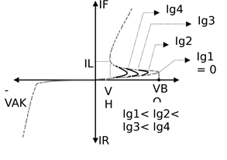

Figure 2. Thyristor Characteristics

In Figure 2 above the breakover voltage Vb, which if the forward SCR voltage reaches this point, the SCR will be ON. Even more important is the current Ig which can cause the voltage Vb to drop to be smaller. The figure shows some Ig currents and their correlation to the breakover voltage. On the SCR datasheet, this gate trigger current is often written in IGT (gate trigger current) notation. The figure also shows the Ih current, namely the holding current that keeps the SCR ON. As already explained, the SCR is conductive, it remains conductive even though the gate current is removed, that is, a power failure on the SCR changes the state from conduction (ON) to non-conducting (OFF) [19 [28]. Substitution or substitution is the process of turning off the SCR. Type of replacement process, for example:

1. The natural switch occurs when the SCR is powered by AC mains [29].
2. Forced switching is carried out when the SCR is given a current source in the same direction, for example through a supply release or a short circuit between A and K for a moment [30].

# RESULTS AND DISCUSSION

**3.1 Circuit Design**

The electrical design is divided into several parts, namely the design of components in the BCR circuit, several things that will be tested in this circuit, namely testing of thyristors, IC regulators, relays, and batteries. From several tests of these components, it is necessary to design a rectifier and voltage regulator. The following is a schematic diagram of the electrical design shown in Figure 3.

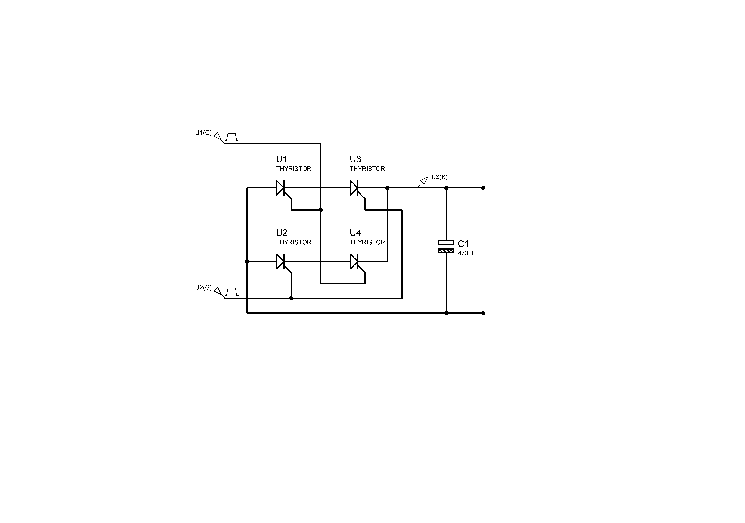

Figure 3. Schematic diagram of the rectifier

In the rectifier circuit, four SCRs will be used, namely thyristors with the bridge method which will produce a direct voltage output with a voltage value that can be adjusted according to the ignition gate. The voltage waveform generated by the rectifier still has ripple or ripple and is not perfect, therefore after the rectifier circuit, electrolytic capacitor will be used as an output wave filter. The following is a schematic diagram of the regulator shown in Figure 4.



Figure 4. L7812 Voltage Regulator Schematic Diagram

Figure 4 above is a voltage regulator circuit that regulates the maximum output voltage of 12 volts dc, this component can be called a stabilizer which is useful so that the voltage remains constant when charging the battery.



Figure 5. Schematic diagram of the overall electrical circuit

Figure 5 is an overall schematic diagram using a rectifier, voltage regulator, and automatic cut-off arrangement.

**3.2 Electronic Design**

The electrical design is specially designed according to the design of the battery charger regulator. In the BCR circuit the components used are 4 Thyristors BT151, ELCO, IC L7812, Resistors, Transistors, Diodes, Zener, Relays, and loads namely 12V/5A Batteries. The application of BCR is to regulate the voltage for charging the battery to a power bank or Uninterruptable Power Supply battery. BCR electronic design drawings can be seen in Figure 6 below.

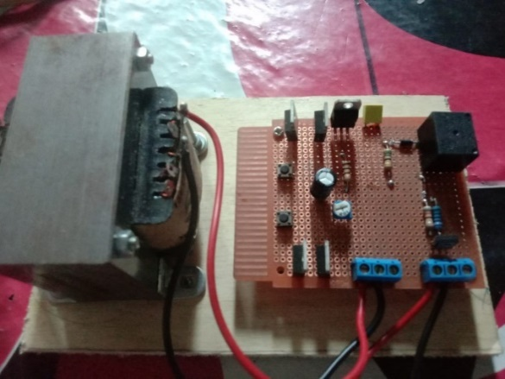

Figure 6. Electronic Battery Charger Regulatory Design

Figure 6 above is an electronic design of a battery charger controller that has been installed on a plywood and circuit board.

Table 1. Thyristor Test Results

|  |  |  |  |  |
| --- | --- | --- | --- | --- |
| NO | *Enter* | Corner | Output | |
| V | Current |
| 1 | AC 15 Volts | 15° | AC 11.22 Volts | 0.1058 A |
| 2 | AC 15 Volts | 30° | AC 10.45 Volts | 0.1045 A |
| 3 | AC 15 Volts | 45° | AC 10.10 Volts | 0.1010 A |
| 4 | AC 15 Volts | 90° | AC 8.71 Volts | 0.0749 A |
| 5 | AC 15 Volts | 180° | AC 3.18 Volts | 0.0318 A |

Table 1 above is the result of the thyristor test by entering an angle of 15 degrees to 180 degrees so that the output varies from 11 volts to 3.18 volts.

Table 2. Transistor and Relay Test Results

|  |  |  |
| --- | --- | --- |
| NO | Voltage | State Relay |
| 1. | 11.11V | Close |
| 2. | 11.56V | Close |
| 3. | 12.59V | Close |
| 4. | 13.45V | Open |

Table 2 above is the result of testing the transistor and relay with the result that the relay opens if the voltage reaches 13.45 volts.

Table 3. L7812 Regulatory IC Test Results

|  |  |  |  |
| --- | --- | --- | --- |
| NO | Resistor Value | Voltage | Performance Status System |
| 1. | 20% | 12.11V | Good |
| 2. | 40% | 12.39V | Good |
| 3. | 60% | 12.72V | Good |
| 4. | 70 % | 12.90V | Good |
| 5. | 80% | 13.45V | Good |

Table 3 above is the result of testing the IC regulator by providing variations in resistance to see the voltage regulated by the IC regulator.

In this test the BCR circuit will be used to charge the UPS battery. In this case, we will pay attention to the source voltage across the thyristor and the voltage on the battery side and the battery charging current which are listed in table 4 below.

Table 4. Battery Charging Test Results

|  |  |  |  |  |  |
| --- | --- | --- | --- | --- | --- |
| NO | Input Voltage | Current | Battery Voltage (DC) | Charging Status | Time (Minute) |
| 1. | 12.11 V | 2.04 A | 10.12 V | ON | 0 |
| 2. | 12.20 V | 2.02 A | 10.34 V | ON | 60 |
| 3. | 12.39 V | 2.01 A | 10.45 V | ON | 120 |
| 4. | 12.48 V | 2.00 A | 10.60 V | ON | 180 |
| 5. | 12.56 V | 1.80 A | 10.70 V | ON | 240 |
| 6. | 12.72 V | 1.60 A | 11.30 V | ON | 300 |
| 7. | 12.77 V | 1.40 A | 11.45 V | ON | 360 |
| 8. | 12.90 V | 0.55 A | 11.66 V | ON | 420 |
| 9. | 13.10 V | 0.45 A | 11.76 V | ON | 480 |
| 10. | 13.20 V | 0.36 A | 11.89 V | ON | 540 |
| 11. | 13.43 V | 0.22 A | 12.00 V | ON | 600 |
| 12. | 13.45 V | 0.10 A | 12.09 V | OFF | 719 |

# CONCLUSION

The conclusion of the research entitled Battery Charger Regulator with Full Controlled Rectifier 15 V/5 A on Uninterruptible Power Supply has been successful and by the original purpose of being able to regulate the charging voltage and battery disconnection automatically. Charging may stop when the battery voltage reaches 13 volts. This value can change if we adjust the thyristor angle. Based on the results of testing the performance of the BCR system, the use of a fully controlled rectifier in the BCR system functions to convert AC voltage from a source (PLN) to DC whose output can be adjusted from 0-12 Volts to become input for battery charging. Regulator IC 7812 regulates that the battery charging voltage does not exceed a predetermined limit.

# REFERENCE

[1] S. Vazquez, E. Zafra, R. P. Aguilera, T. Geyer, J. I. Leon, and L. G. Franquelo, “Prediction model with harmonic load current components for FCS-MPC of an uninterruptible power supply,” *IEEE Trans. Power Electron.*, vol. 37, no. 1, pp. 322–331, 2021.

[2] A. Hasibuan, M. Daud, R. Kurniawan, W. V. Siregar, P. A. Safna, and others, “Comparison Analysis Of Electricity Use By State Electricity Company With Renewable Energy Sources In Household Type 54,” in *2022 6th International Conference on Electrical, Telecommunication and Computer Engineering (ELTICOM)*, 2022, pp. 24–29.

[3] R. Kurniawan, M. Daud, and A. Hasibuan, “Impact of Intermittent Renewable Energy Generations Penetration on Harmonics in Microgrid Distribution Networks,” in *2022 6th International Conference on Electrical, Telecommunication and Computer Engineering (ELTICOM)*, 2022, pp. 30–37.

[4] M. F. Hordeski, *Emergency and Backup Power Sources: Preparing for Blackouts and Brownouts*. CRC Press, 2020.

[5] F. S. Lukman, A. Hasibuan, A. Setiawan, and M. Daud, “Performance of 25 KWP rooftop solar PV at misbahul ulum building, Lhokseumawe City,” in *2020 4rd International Conference on Electrical, Telecommunication and Computer Engineering (ELTICOM)*, 2020, pp. 81–86.

[6] H. Mubarak, A. Hasibuan, A. Setiawan, and M. Daud, “Optimal Power Analysis for the Installation of On-Grid Rooftop Photovoltaic Solar Systems (RPVSS) in the Industrial Engineering Laboraturiom Building, Bukit Indah Universitas Malikussaleh Lhokseumawe Aceh,” in *2020 4rd International Conference on Electrical, Telecommunication and Computer Engineering (ELTICOM)*, 2020, pp. 44–47.

[7] D. Shahzad, S. Pervaiz, N. A. Zaffar, and K. K. Afridi, “GaN-based high-power-density AC--DC--AC converter for single-phase transformerless online uninterruptible power supply,” *IEEE Trans. Power Electron.*, vol. 36, no. 12, pp. 13968–13984, 2021.

[8] A. Hasibuan, M. Daud, M. Sayuti, F. Hidayatullah, W. V. Siregar, and R. Fachroji, “Utilization of Small Wind Turbines as Source Alternative Electrical Energy for Lighting in the Banyak Island Tourism Area, Aceh Singkil, Indonesia,” in *2022 6th International Conference on Electrical, Telecommunication and Computer Engineering (ELTICOM)*, 2022, pp. 44–47.

[9] A. Joseph and M. Shahidehpour, “Battery storage systems in electric power systems,” in *2006 IEEE Power Engineering Society General Meeting*, 2006, pp. 8 pp.-. doi: 10.1109/PES.2006.1709235.

[10] Q. Lin, F. Cai, W. Wang, S. Chen, Z. Zhang, and S. You, “A high-performance online uninterruptible power supply (UPS) system based on multitask decomposition,” *IEEE Trans. Ind. Appl.*, vol. 55, no. 6, pp. 7575–7585, 2019.

[11] Q. Ouyang, Z. Wang, K. Liu, G. Xu, and Y. Li, “Optimal charging control for lithium-ion battery packs: A distributed average tracking approach,” *IEEE Trans. Ind. Informatics*, vol. 16, no. 5, pp. 3430–3438, 2019.

[12] S. A. Rotenberg, S. K. Podilchak, P. D. H. Re, C. Mateo-Segura, G. Goussetis, and J. Lee, “Efficient rectifier for wireless power transmission systems,” *IEEE Trans. Microw. Theory Tech.*, vol. 68, no. 5, pp. 1921–1932, 2020.

[13] M. Ferraro, G. Brunaccini, F. Sergi, D. Aloisio, N. Randazzo, and V. Antonucci, “From Uninterruptible Power Supply to resilient smart micro grid: The case of a battery storage at telecommunication station,” *J. Energy Storage*, vol. 28, p. 101207, 2020.

[14] B. J. Huang, P. C. Hsu, M. S. Wu, and P. Y. Ho, “System dynamic model and charging control of lead-acid battery for stand-alone solar PV system,” *Sol. Energy*, vol. 84, no. 5, pp. 822–830, 2010.

[15] A. K. Venkitaraman and V. S. R. Kosuru, “Hybrid Deep Learning Mechanism for Charging Control and Management of Electric Vehicles,” *Eur. J. Electr. Eng. Comput. Sci.*, vol. 7, no. 1, pp. 38–46, Jan. 2023, doi: 10.24018/EJECE.2023.7.1.485.

[16] A. F. Bendary and M. M. Ismail, “Battery Charge Management for Hybrid PV/Wind/Fuel Cell with Storage Battery,” *Energy Procedia*, vol. 162, pp. 107–116, Apr. 2019, doi: 10.1016/J.EGYPRO.2019.04.012.

[17] N. I. Nimalsiri, C. P. Mediwaththe, E. L. Ratnam, M. Shaw, D. B. Smith, and S. K. Halgamuge, “A Survey of Algorithms for Distributed Charging Control of Electric Vehicles in Smart Grid,” *IEEE Trans. Intell. Transp. Syst.*, vol. 21, no. 11, pp. 4497–4515, Nov. 2020, doi: 10.1109/TITS.2019.2943620.

[18] X. Zhu *et al.*, “Silicon-Controlled Rectifier Embedded Diode for 7 nm FinFET Process Electrostatic Discharge Protection,” *Nanomater. 2022, Vol. 12, Page 1743*, vol. 12, no. 10, p. 1743, May 2022, doi: 10.3390/NANO12101743.

[19] F. Du *et al.*, “An improved silicon-controlled rectifier (SCR) for low-voltage ESD application,” *IEEE Trans. Electron Devices*, vol. 67, no. 2, pp. 576–581, Feb. 2020, doi: 10.1109/TED.2019.2961124.

[20] R. Singh, S. M. Amrr, and M. S. Jamil Asghar, “Supervisory control strategy for the effective solar energy utilization in a residential microgrid system using a cost-effective controller,” *Int. J. Electr. Power Energy Syst.*, vol. 132, no. April, p. 107170, 2021, doi: 10.1016/j.ijepes.2021.107170.

[21] K. Il Do, B. Lee, S. G. Kim, and Y. S. Koo, “Design of 4H-SiC-Based Silicon-Controlled Rectifier with High Holding Voltage Using Segment Topology for High-Voltage ESD Protection,” *IEEE Electron Device Lett.*, vol. 41, no. 11, pp. 1669–1672, Nov. 2020, doi: 10.1109/LED.2020.3022888.

[22] M. J. Lencwe, S. D. Chowdhury, S. Mahlangu, M. Sibanyoni, and L. Ngoma, “An efficient HVAC network control for safety enhancement of a typical uninterrupted power supply battery storage room,” *Energies*, vol. 14, no. 16, 2021, doi: 10.3390/en14165155.

[23] S. Singh, P. Rathore, V. K. Tayal, and S. K. Sinha, “Improved Design of Automatic Car Battery Charging System,” *2019 2nd Int. Conf. Power Energy Environ. Intell. Control. PEEIC 2019*, pp. 1–5, Oct. 2019, doi: 10.1109/PEEIC47157.2019.8976567.

[24] M. N. Mahmud and N. Ramdon, “Development of UPS for Pedestrian Traffic Light Using Solar- Piezo and Grid Power Supplies,” vol. 3, no. 1, pp. 477–489, 2022.

[25] I. Kuzmin, A. Loskutov, E. Osetrov, and A. Kurkin, “Source for Autonomous Power Supply System Based on Flow Battery,” *Energies*, vol. 15, no. 9, 2022, doi: 10.3390/en15093027.

[26] P. Renz, M. Lueders, and B. Wicht, “A 47 MHz Hybrid Resonant SC Converter with Digital Switch Conductance Regulation and Multi-Mode Control for Li-Ion Battery Applications,” *Conf. Proc. - IEEE Appl. Power Electron. Conf. Expo. - APEC*, vol. 2020-March, pp. 15–18, Mar. 2020, doi: 10.1109/APEC39645.2020.9124238.

[27] Z. Li, X. Shi, M. Shi, C. Wei, F. Di, and H. Sun, “Investigation on the Impact of the HPPC Profile on the Battery ECM Parameters’ Offline Identification,” *2020 Asia Energy Electr. Eng. Symp. AEEES 2020*, pp. 753–757, May 2020, doi: 10.1109/AEEES48850.2020.9121487.

[28] H. Tafekirt, J. Pelegri-Sebastia, A. Bouajaj, and B. M. Reda, “A Sensitive Triple-Band Rectifier for Energy Harvesting Applications,” *IEEE Access*, vol. 8, pp. 73659–73664, 2020, doi: 10.1109/ACCESS.2020.2986797.

[29] M. Li and X. Jing, “A bistable X-structured electromagnetic wave energy converter with a novel mechanical-motion-rectifier: Design, analysis, and experimental tests,” *Energy Convers. Manag.*, vol. 244, p. 114466, Sep. 2021, doi: 10.1016/J.ENCONMAN.2021.114466.

[30] M. M. Mansour and H. Kanaya, “High-Efficient Broadband CPW RF Rectifier for Wireless Energy Harvesting,” *IEEE Microw. Wirel. Components Lett.*, vol. 29, no. 4, pp. 288–290, Apr. 2019, doi: 10.1109/LMWC.2019.2902461.

# BIOGRAPHY FROM WRITER

|  |  |
| --- | --- |
| C:\Users\Arnawan\Downloads\WhatsApp Image 2021-08-08 at 13.11.16.jpeg | **Arnawan Hasibuan**,  Associate Professor at Faculty of Engineering in Universitas Malikussaleh, Aceh, Indonesia. He works as senior lecturer and researcher at Undergraduate Program of Electrical Engineering and Master Program of Renewable Energy Engineering. Interest in research in the field of Power Systems, Renewable Energy, System Control. Apart from teaching, he is also active as chief editor at the Journal of Renewable Energy, Electrical, and Computer Engineering (JREECE) and the Jurnal Solusi Masyarakat Dikara (JSMD). He can become contacted on email: [arnawan@unimal.ac.id](mailto:arnawan@unimal.ac.id)  Link GS : <https://scholar.google.com/citations?user=OSRbduIAAAAJ&hl=en&oi=ao>  Link Scopus : <https://www.scopus.com/authid/detail.uri?authorId=55755404500>  Link Sinta : <https://sinta.ristekbrin.go.id/authors/detail?id=6017142&view=overview>  Link ORCID : <https://orcid.org/my-orcid?orcid=0000-0003-3864-9107>  Link WoS : <https://www.webofscience.com/wos/author/record/IXX-0008-2023> |
|  | **Muhammad Daud,**  Associate Professor at Faculty of Engineering in Universitas Malikussaleh, Aceh, Indonesia. He works as senior lecturer and researcher at Undergraduate Program of Electrical Engineering, Master Program of Renewable Energy Engineering, and Master Program of Information Technology. Interest in research in the field of Power Systems, Renewable Energy, Telecommunications. Apart from teaching, he is also active as Co-Chief Editor at the Journal of Renewable Energy, Electrical, and Computer Engineering (JREECE). Currently as dean at the Faculty of Engineering, Universitas Malikussaleh. He can become contacted on email: [mdaud@unimal.ac.id](mailto:mdaud@unimal.ac.id)  Link GS : <https://scholar.google.com/citations?user=CkFSNXsAAAAJ&hl=en>  Link Scopus : <https://www.scopus.com/authid/detail.uri?authorId=56648306300>  Link Orcid : <https://orcid.org/0000-0003-1102-0253>  Link Sinta : <https://sinta.kemdikbud.go.id/authors/profile/5973239> |
|  | **Rizki Shobirin Hutagalung**  Student of Electrical Engineering Study Program in Faculty of Engineering, Universitas Malikussaleh, Aceh, Indonesia. He is also a research assistant and practicum assistant at the Unimal Electrical Engineering Laboratory. He can become contacted on email: [rizki.180150119@mhs.unimal.ac.id](mailto:rizki.180150119@mhs.unimal.ac.id) |
|  | **Kartika**  Associate Professor at Faculty of Engineering in Universitas Malikussaleh, Aceh, Indonesia. He works as senior lecturer and researcher at Undergraduate Program of Electrical Engineering. Interest in research in the field of Power Systems, Control Systems, Electronics and Robotic. He can become contacted on email: [kartika@unimal.ac.id](mailto:kartika@unimal.ac.id)  Link GS : <https://scholar.google.com/citations?user=y5gRB5EAAAAJ&hl=en&oi=sra> |
| I Made Ari Nrartha | **I Made Ari Nrartha**  Associate Professor at Faculty of Engineering in Mataram University, Nusa Tenggara Barat, Indonesia. Interest in research in the field of Power Systems, Renewable Energy, System Control. He can become contacted on email: [nrartha@unram.ac.id](mailto:nrartha@unram.ac.id)  Link GS : <https://scholar.google.com/citations?user=B61LC6wAAAAJ&hl=en>  Link Scopus : <https://www.scopus.com/authid/detail.uri?authorId=55946635800>  Link Orcid : <https://orcid.org/0000-0001-9779-5759> |
|  | **Rizky Almunadiansyah**  Student of Electrical Engineering Study Program in Faculty of Engineering, Universitas Malikussaleh, Aceh, Indonesia. He is also a research assistant and practicum assistant at the Unimal Electrical Engineering Laboratory. He can become contacted on email: [rizky.200150036@mhs.unimal.ac.id](mailto:rizky.200150036@mhs.unimal.ac.id) |